# **Trello**

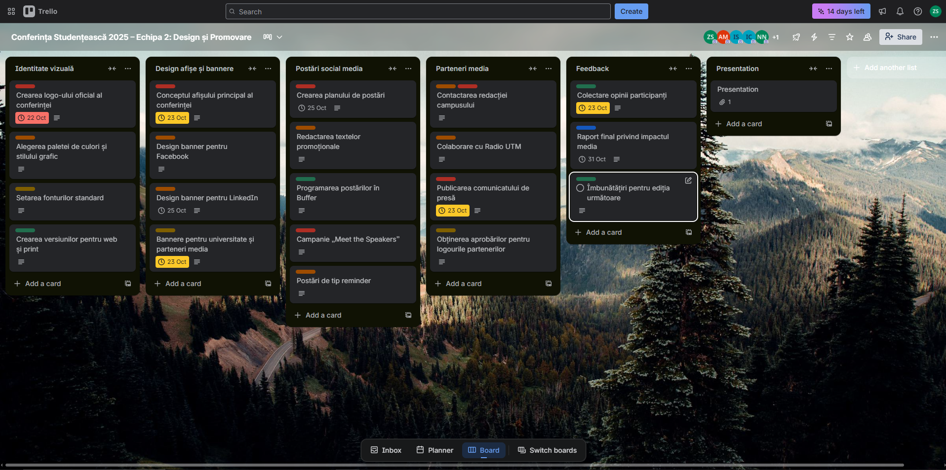([link](https://trello.com/invite/b/68f884f51db064184c6218c4/ATTI94388a9425f5dece97225b46d207c052B7699B64/conferin%C8%9Ba-studen%C8%9Beasca-2025-echipa-2-design-%C8%99i-promovare))